First Steps with Power Apps for Excel Users
Step-by-Step Demo Notes
From Excel table to deployed app

Creating a Power App from Excel

Goal: Turn an Excel table into a 3-screen browsable, editable app.
1. Open make.powerapps.com
2. Apps → Start with an app template → From Excel
3. Select your OneDrive / SharePoint connection
4. Find your file and select the correct Table — data must be a proper Excel Table, not a plain range
5. Click Connect — wait for the app to build

If you get a connection error, try these in order:
A. Data pane → three dots → Refresh
B. Save the app, close it, reopen and try again
C. Remove the data source entirely and re-add it:
→ Add data → Connectors → Excel Online → locate file → Connect → select table
→ When prompted: choose Use the unique column (don't generate a new ID — it already exists)
→ After reconnecting: go to Edit Screen → find the PowerAppsId card → Delete it

⚠ | Excel data MUST be formatted as a Table. Plain ranges will not work.

If this happens Power Apps ID will need to be added manually. Can automate this with the GUID() formula.

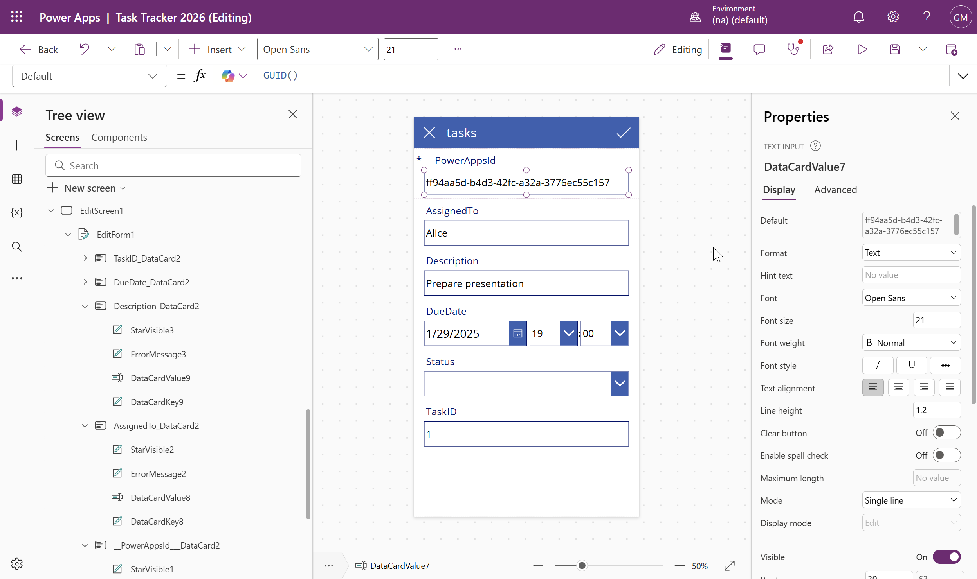

⚠ | If all else fails: import the Excel table as a SharePoint list and connect from there. Exercise Files include instructions. See Create a list from Microsoft Excel for a walkthrough.

6. Explore the Tree View — click the card icon on the left sidebar
→ Browse Screen 1 — list of all records (entry point)
→ Detail Screen 1 — full record view
→ Edit Screen 1 — edit a record
7. Click the header to rename it — just type the new name and hit Enter
8. Click the large container on Browse Screen — Power Fx appears in the formula bar; use Fields / Layout in the sidebar to adjust what's shown

Modifying your Power App

Goal: Add data validation: required field, status dropdown, date restriction.
Make a field required
1. Go to Edit Screen → click the field (e.g., Description)
2. Right panel → Advanced tab → click Unlock
3. Set Required to true
→ An asterisk (*) appears on the canvas confirming the change

⚠ | The field is locked by default. Required is grayed out until you click Unlock.

Add a status dropdown (Allowed Values)
1. Edit Screen → click the Status field
2. Right panel → Display tab → click Edit next to Field

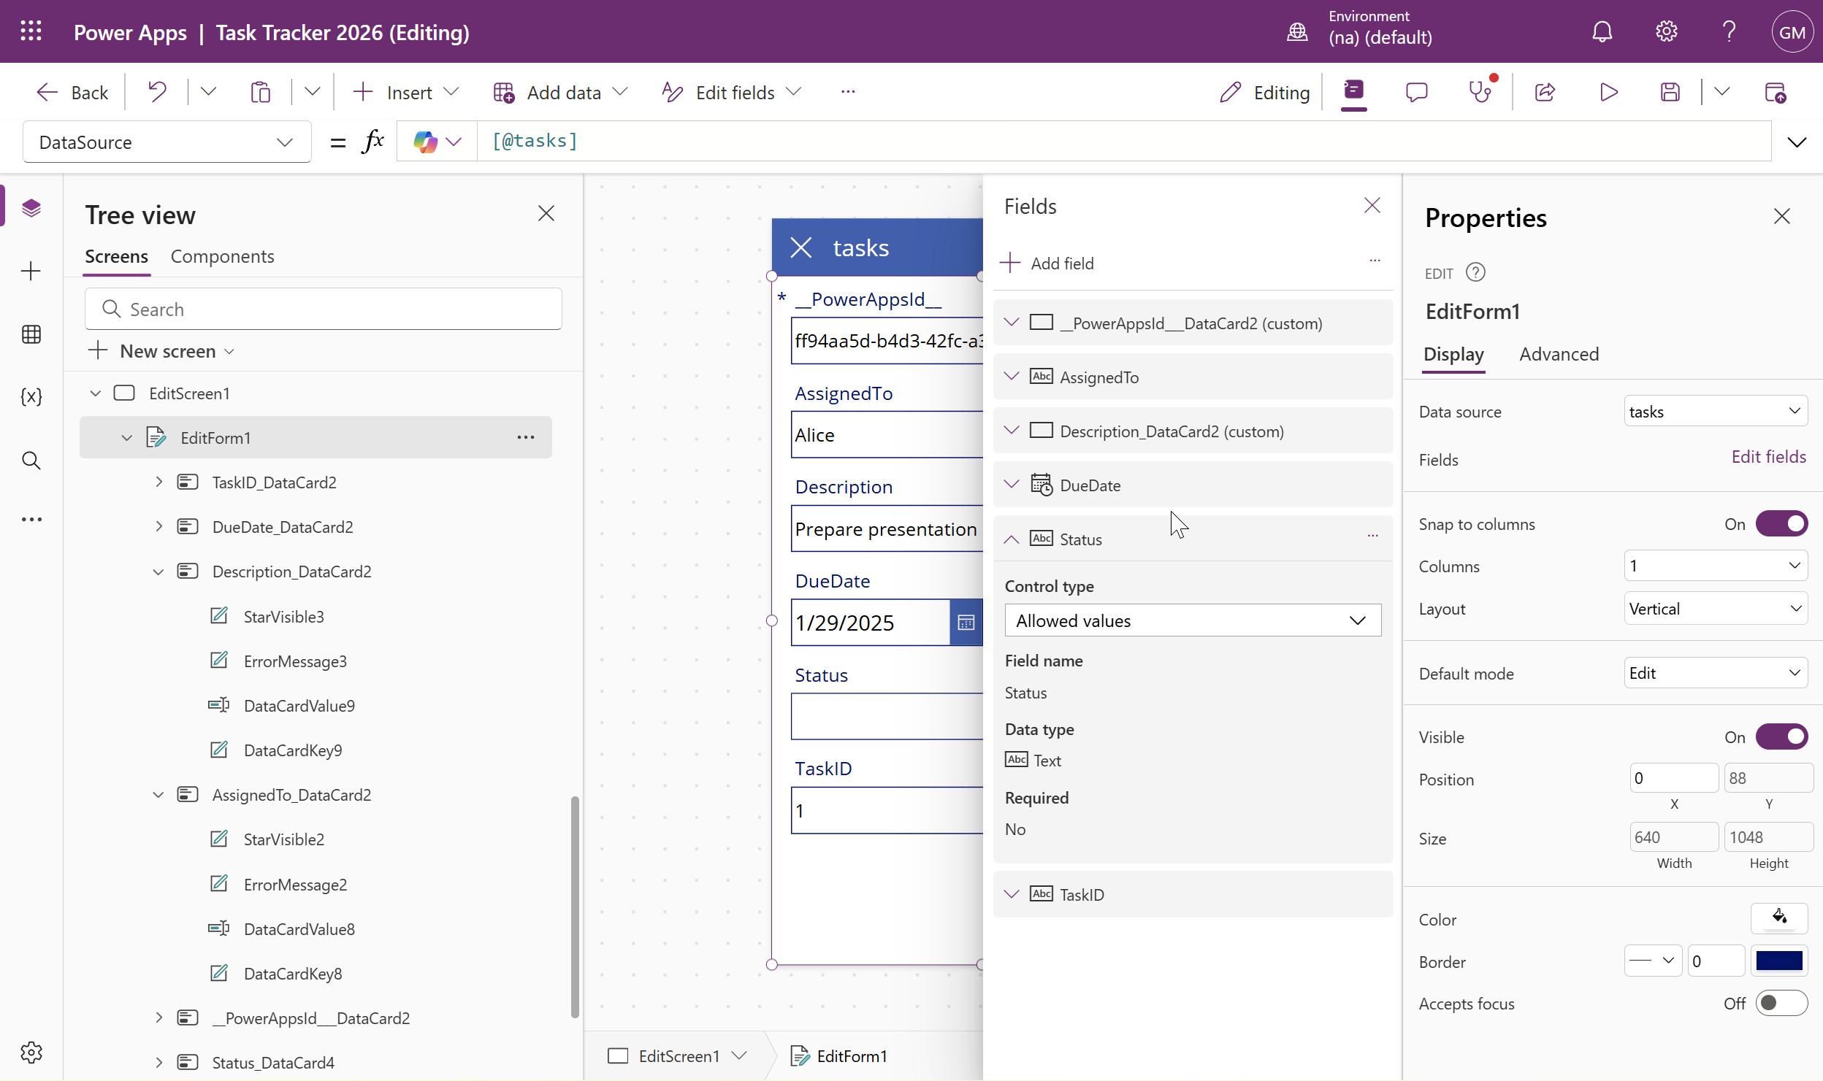

3. Change Control Type to Allowed Values
4. Advanced tab → click Unlock
5. Scroll to Items under the Data group
6. Replace AllowedValues with your list:
["Not Started","On Track","Completed"]

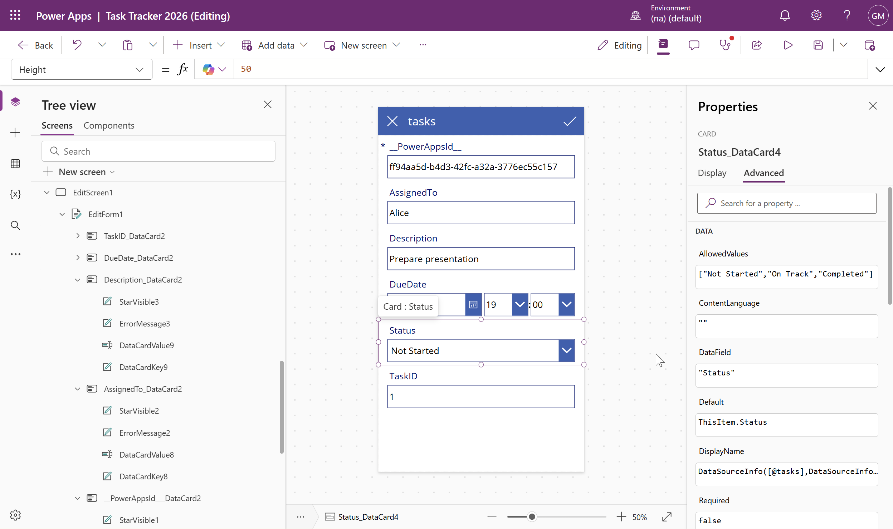

⚠ | Power Apps is extremely finicky here. Double quotes on every value, square brackets, commas between items. One wrong character breaks it.

Add date validation (no past dates)
- Edit Screen → click the Due Date field → Unlock

2. Click directly on the date button/field itself
3. Find the OnChange property in the property dropdown
4. Paste in the Power FX formula — provided in the Exercise Files

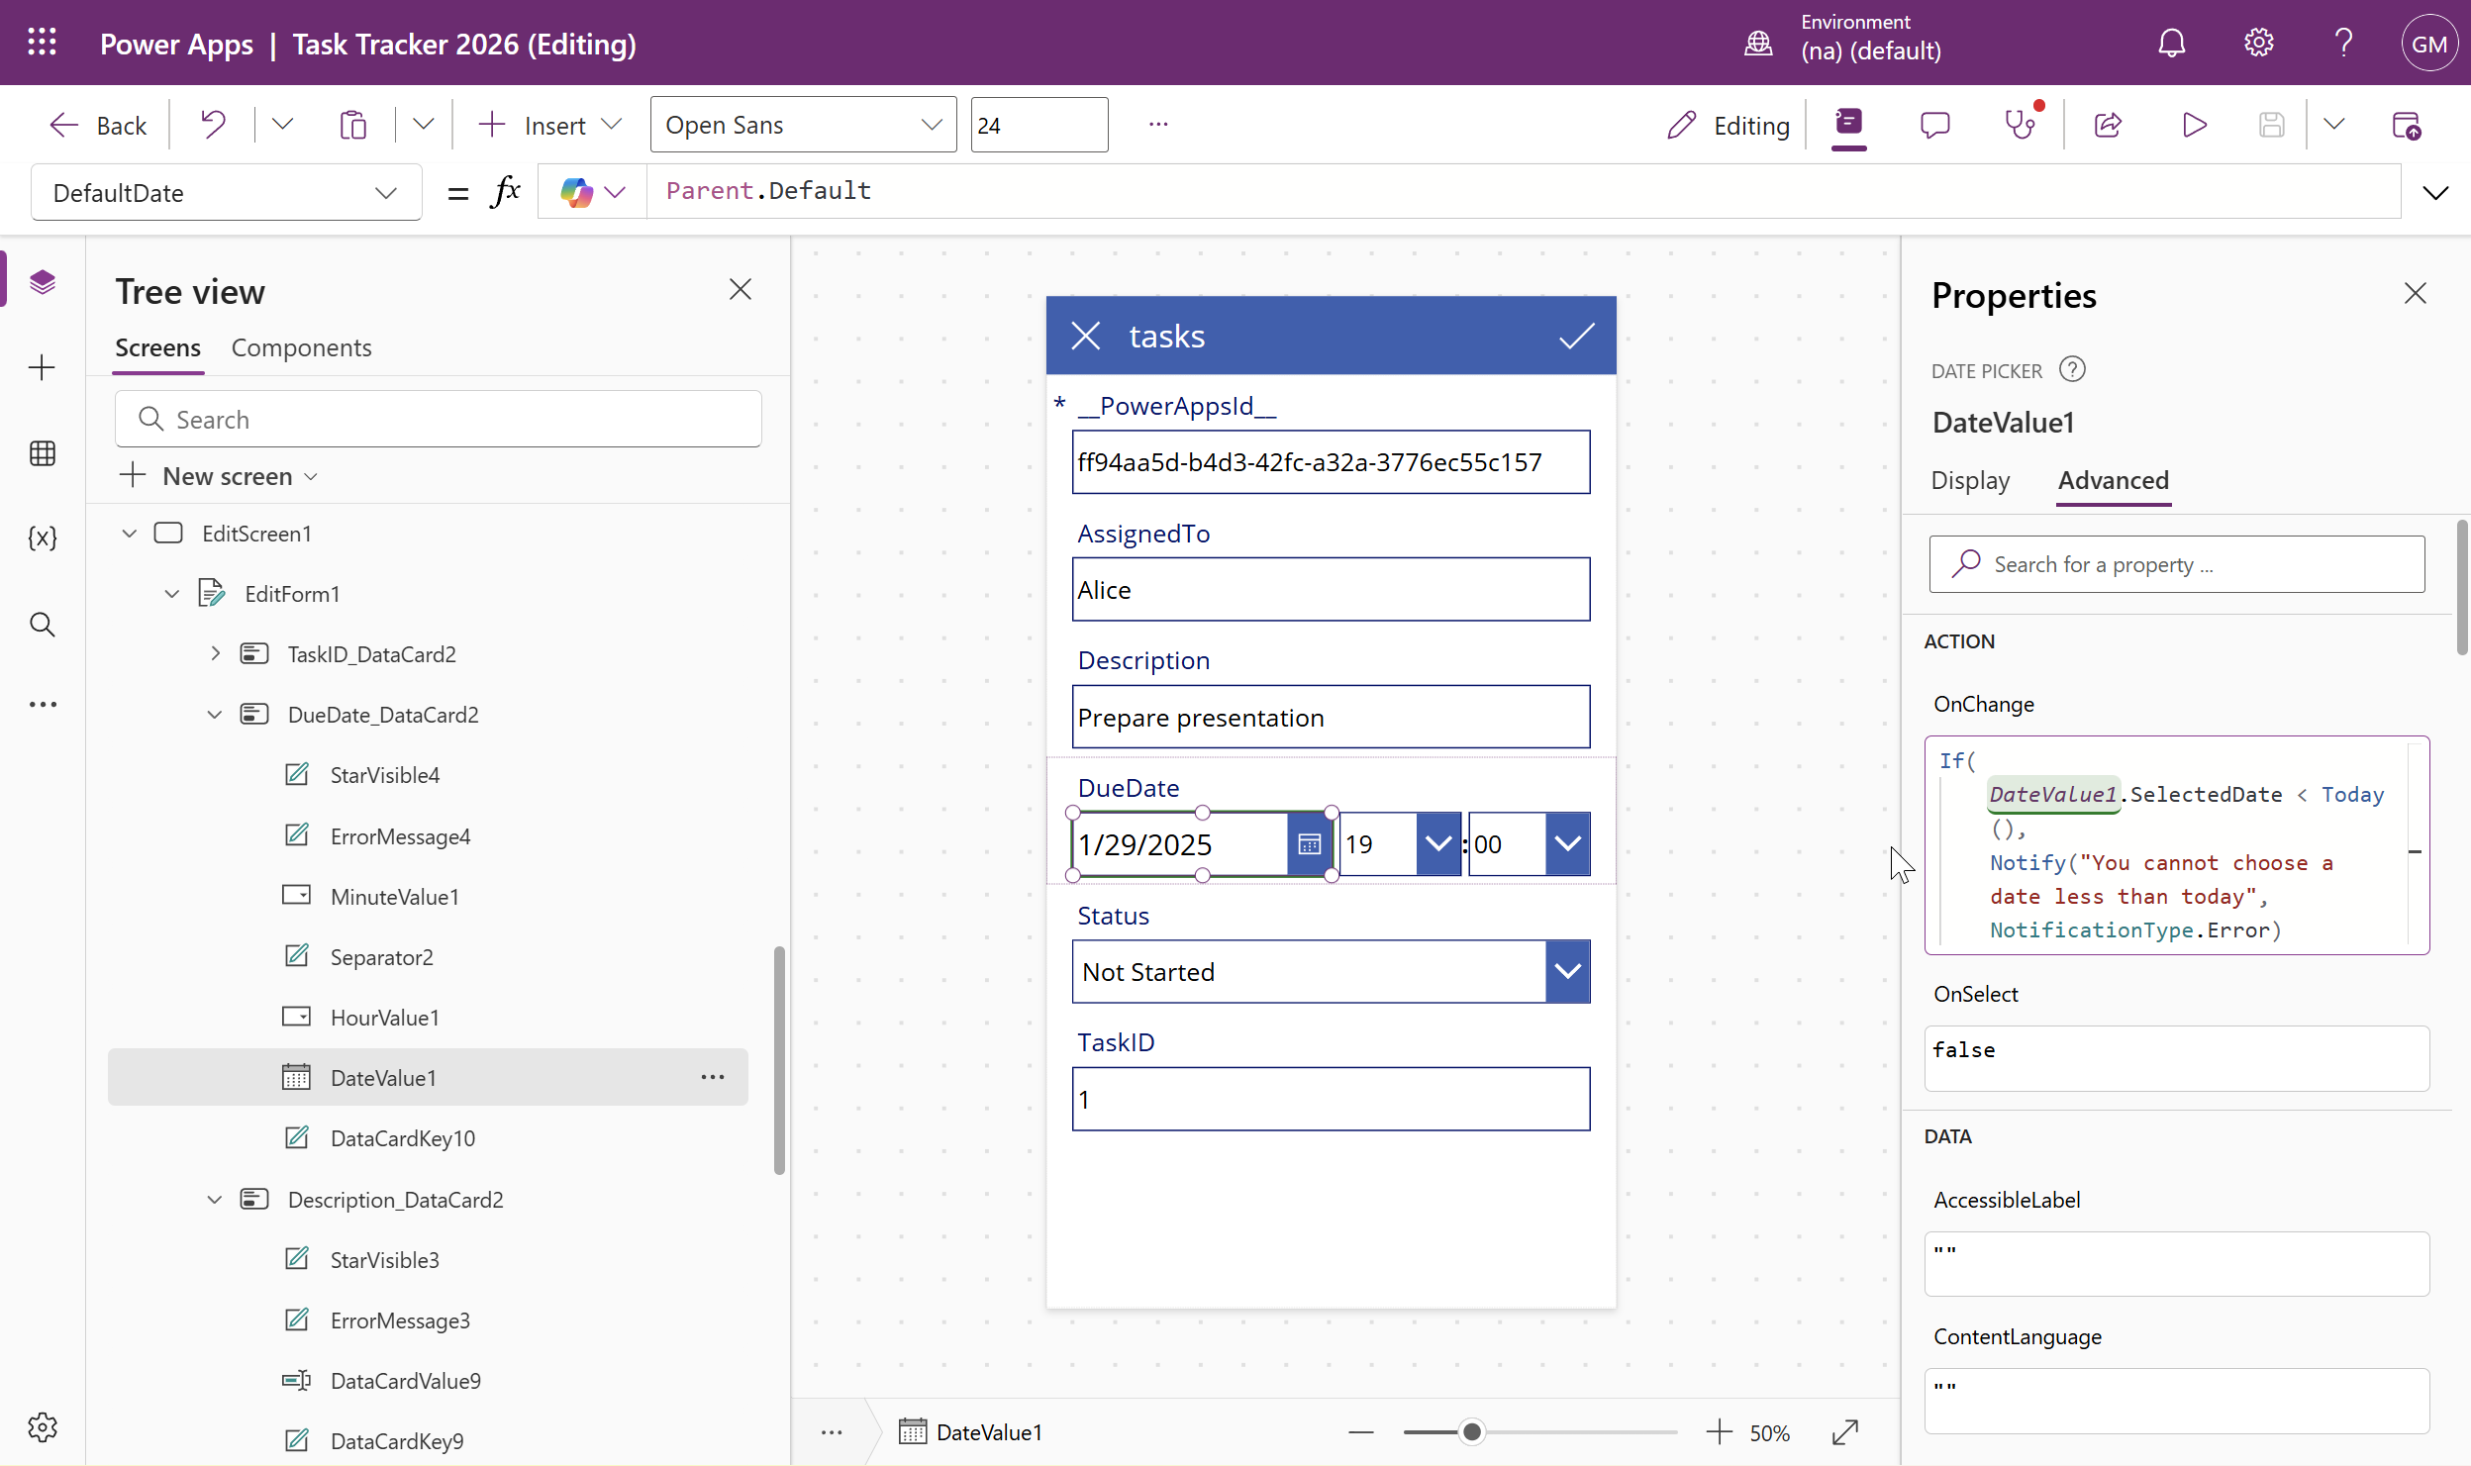

⚠ | Test it in preview: picking a past date should show a warning; a future date should save fine.

Deploying your Power App

Goal: Get the app in front of users — via share link, mobile app, or ZIP export.
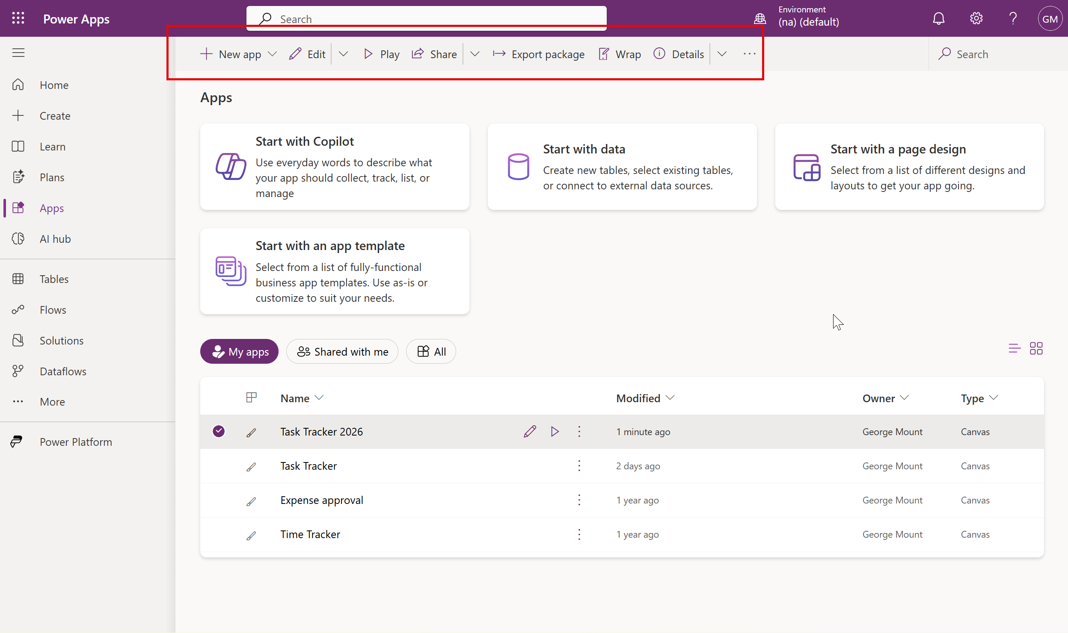

1. make.powerapps.com → Apps → find your app → click Share
→ You'll see a warning about data permissions — users also need access to the Excel file
→ Go to OneDrive and share the workbook with your intended users (or limit to specific people)
2. Mobile access: users download the Power Apps app (iOS or Android) and access from there
3. Quick export (no pipeline setup): three dots → Export package → name it → export as ZIP

⚠ | Sharing an Excel file as the data back-end carries real risks: accidental edits, corruption, no access controls. For anything serious, consider Dataverse or a SharePoint list instead.

⚠ | ZIP export is simple but lacks version control. For proper deployment across environments, look into Solutions and Pipelines — but that is a future step.

Creating a Power App with images

Goal: Build a searchable, editable app from a new dataset that includes image URLs.
1. make.powerapps.com → Apps → Start with app template → From Excel
2. Point to the challenge workbook → select the Property Maintenance table → Connect

Format the Browse Screen layout
3. Click the large container → Layout → select Image, Title, and Subtitle
4. Under Fields: set Subtitle → Status, Title → Description of Issue
→ Power Apps may add prefixes or symbols to field names — match what it shows exactly

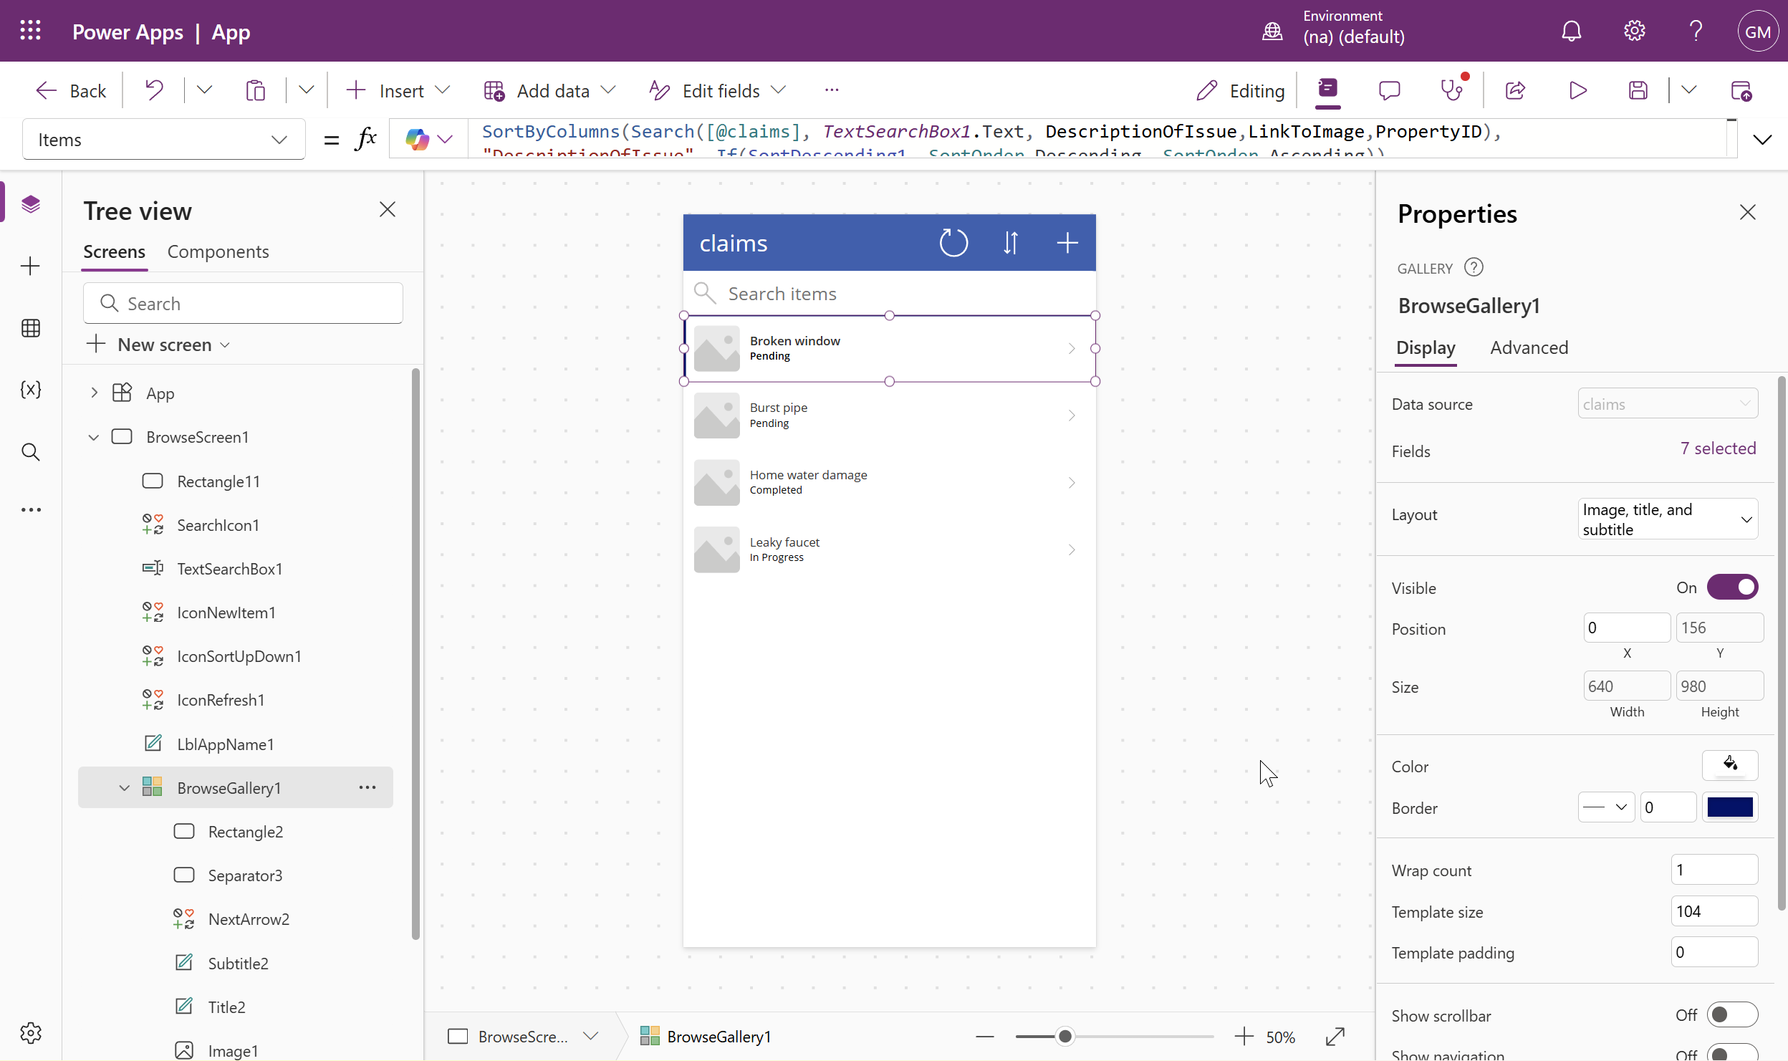

Show images from URL column
5. Click the gray image placeholder on the first record in Browse Screen
6. In the formula bar, it will say SampleImage — replace it with:
ThisItem.'LinkToImage'

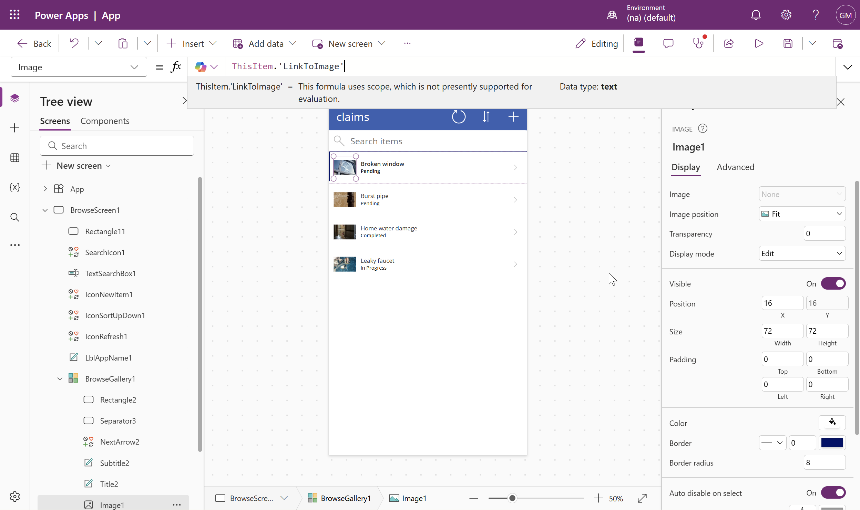

⚠ | Single quotes around the field name are required. Match the exact casing of your column. The images will populate across all records once this is set.

Make Description required + add Status dropdown
7. Edit Screen → Description field → Advanced → Unlock → Required: true
8. Edit Screen → Status field → Display → Edit → Control Type: Allowed Values
9. Advanced → Unlock → Items (under Data) → replace with:
["Under Review","Scheduled","In Progress","Completed"]

Test before sharing
10. Save the app
11. Browse Screen → Play ▶ to enter preview mode
12. Add a new record — paste in the sample image URL from the text file to confirm images render
13. Exit preview → OK → Save

⚠ | If you see a stray first record from a failed import, go to Edit Screen → find it in the tree → delete it.

